UNIT/03: EDUCATION AND EMPLOYMENT
READING
IN THIS unIT YOU WILL
LEARN HOW TO
- identify the main ideas of a passage
- find information in a text quickly
- deal with multiple-choice questions.

Lead-in

01 | Tell your partner about the house or apartment you live in.

02 | What kind of house would you like to live in?  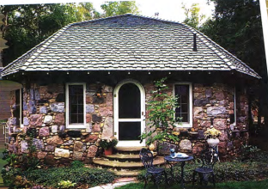 a house in the country 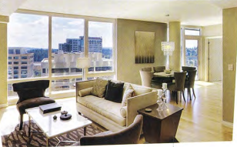 a luxury apartment in the city  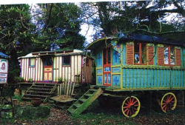  a caravan

03 | Find these in the pictures on this page.  igloo treehouse houseboat shipping container homes  Which ones would you like to live in?  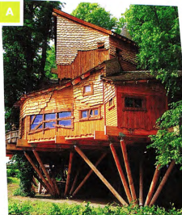 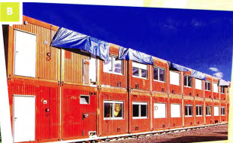  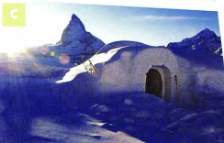 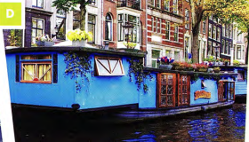
SKIMMING AND SCANNING A TEXT

◉ The skills of skimming and scanning are very important in the Reading test.
Skimming is reading the passage quickly to get an idea of what it is about.
Scanning is also reading the passage quickly, but this time looking for particular information in the text, for example, the answer to a question.
- Before you look at the questions, read through the passage quickly. Don't spend more than a minute on this.
- Skim over (don't spend time on) words like the, they, our, through.
- Notice the 'content' words, such as nouns and verbs, to get an idea of what the passage is about.
- Read the questions.
- Scan the passage for the answers. Let your eyes move quickly over the text until you see one of the key words from the question, or words that have a similar meaning.
- Read that part of the passage carefully until you find the answer.

04 | What is the passage about? Read it in ONE minute and choose one of the options.  - Life in different cities around the world  - Unusual places to live or stay around the world  The type of houses and flats most people live in
05 | Read the passage again to find the words from the box in exercise 3 as quickly as you can.
06 | Which of the two activities you have just done practised scanning? Which practised skimming?  AMAZING HOMES  Most people live in a house or a flat. When they go on holiday they stay in a hotel or a guest house. But some places where you can live or stay are a bit different.  - One unusual place to live is a houseboat. Amsterdam in Holland is famous for its houseboats - there are about 2,500 of them. They have everything that a normal house has: a living room, bedroom, kitchen, bathroom and even sometimes a terrace on the roof. They are cheaper than houses and people who live on houseboats enjoy being close to nature. Some houseboats can be moved to other parts of the river, while others are permanently in one place.  - In Tokyo, Japan, there is a see-through house. It is like a normal Japanese house but all the walls are made of glass. There is plenty of daylight but no privacy. Architect Sou Fujimoto designed it for a couple to make their home. He based his ideas on early man living in trees. It wouldn't suit everyone but the couple who live there love the feeling of being surrounded by the natural world.  - All around the world, people live in homes made from shipping containers. Some use only one container, while others are made from several containers joined together. One house in Chile was built from 12 containers. They are cheap to buy and eco-friendly. They can also be placed in the garden or drive as guest rooms, studies or utility rooms.  - in Germany, you can stay in a one-metre-square house, the smallest house in the world, called the House NA. Van Bo Le-Mentzel, a refugee from Laos, built it to draw attention to the world housing shortage. It is a wooden structure on wheels and weighs 40 kg. It has a locking door and a window. You can turn it onto its side when you want to lie down. Franz from Munich spent the night in one recently 'just to see what it was like'. He found it a bit uncomfortable!  - For an unusual holiday you can stay in an igloo, a house made of ice. These can be found in several countries including Sweden, Norway and Finland. They are built new every winter. Jenny and Callum, visitors from Australia, told us, 'We slept in an igloo last night. It's so cold here - minus 5 degrees centigrade. We used reindeer skins to keep warm!"  - Another couple, Shaun and Rachel from Manchester, enjoyed a recent holiday in a treehouse in Sussex, England. They said, 'It was right up in the trees and had everything we needed, even wifi! It had a small kitchen and we did our own cooking. It was the perfect place to get away from our busy lives.

UNDERSTANDING PARAPHRASE

◉ In the Reading paper, it is very important to be able to understand paraphrase (when the same idea is given using different words). The words used in the questions won't be exactly the same as the ones in the passage.

07 | Match these words and phrases from the text (1-6) with their paraphrases (a-f).  - houseboats - permanently - privacy - surrounded by the natural world - uncomfortable - Sweden, Norway and Finland - not being watched by others - not feeling pleasant - homes on the water - Nordic countries - forever, always - having nature all around
08 | Choose the best paraphrase for these sentences from the text.  - The treehouse had everything we needed.  - We needed some more things for our stay in the treehouse.  - The treehouse was very well equipped.  - We need everything for the treehouse.  - Some houseboats can be moved to other parts of the river.  - Not all houseboats are permanently fixed in one place.  - Only some parts of the river have houseboats.  - You can move to a houseboat in another part of the river.  - One house in Chile was built from 12 containers.  - There are 12 houses in Chile made from containers.  - 12 containers were used to make one house.  - You need 12 containers to make a house in Chile.

[[[[[[[[[[SENTENCE COMPLETION]

◉ in this task type you will have to complete a sentence with up to three words (or two words and/or a number) taken from the passage. The instructions will tell you how many words you are allowed to use.
Look at this example: Houseboat occupants like living
This is a paraphrase of the following sentence from the passage
People who live on houseboats enjoy being close to nature.
Because you have to use words from the passage in your answer, the answer is close to nature.

09 | Follow the steps in the box opposite and complete the sentences.  Choose NO MORE THAN TWO WORDS from the passage for each answer.  - The two people who live in the transparent house love it, but it wouldn't ---.  - The designer of the smallest house hopes to --- to the lack of houses all over the world.  - People who stay in igloos sometimes protect themselves from the cold by making use of ---.  - People who have --- would find a holiday in a treehouse ideal. | ◉ How to do sentence completion questions  - Underline key words from the sentence (houseboat occupants, in the above example).  - Scan the text for the key words or words that mean something similar (people who live on houseboats has a similar meaning to houseboat occupants).  - Read the sentences near the key words carefully-like living means the same as enjoy being.  - Find the words that seem to fit the sentence.  - Check that the meaning of the sentence matches the meaning of the text.  - Check the grammar of the completed sentence.  - Check if the word(s) should be singular or plural.  - Check that you have used the correct number of words.

GRAMMAR FOCUS: PAST SIMPLE AND PRESENT SIMPLE

10 | Answer the questions in exercise 5. Follow the advice in the box.  - Which tenses does the passage use?  - present tenses  - past tenses  - both present and past tenses  - Which tenses are used:  - to describe the houses?  - to describe habit or things that are always true?  - to describe people's experiences on holidays?  - to talk about designing or building the house? | TIP 10  As part of your first quick look at the passage, identify whether it is written mainly in the past, present or future, and if the tense changes. This may help you understand the passage.
11 | Choose the correct verb, present simple or past simple.  - Most people in China live / lived in flats.  - In the UK most houses have / had gardens.  - In 2010, my parents move / moved to Australia.  - Nowadays Sarah usually spends/spent her holidays in cities.  - In the past she prefers / preferred beach holidays.
12 | Complete the sentences with the correct form of the verb in brackets.  - Farid now --- (share) a flat with some other students.  - Last year he --- (live) at home with his parents.  - Once I --- (stay) on a campsite next to a lake in Italy.  - My flat --- (have) two balconies.  - In 2014 we --- (move) into our new house.

[[[[[[[[[[EXAM SKILLS]
HOME FROM HOME

I remember feeling the first time I left home that I would never be able to feel at home anywhere but in my home. No other place would have my mum and dad, my annoying little brother and my cat, Tilly. Nowhere would smell like my home - my mum's roast chicken in the oven and the salty, seaweed smell that drifted in from the nearby beach. The sound of seagulls squawking was the sound of home. Nowhere else would I feel comfortable enough to put my feet up under me and gaze into the log fire dreaming of the future.  I was 15 when I first went away from home on a school trip to Germany. My friends were going too, but we would all stay with different families. I was nervous about this. I knew the home I was going to would not be as comfortable as mine, the family would not be as kind, and who knew what the German food would be like? I knew I would spend three weeks, homesick and sad, missing my family back home.  We arrived in Germany late at night after a long journey by coach and boat. I was tired and hungry. We went into the school hall, where the host families were waiting to meet us. I wondered which one would be mine. Would they give me dinner at this time and would I be able to eat the unfamiliar food? Suddenly I heard my name called and the name of my exchange partner, Brigitte Schmitt. A pretty, blonde girl stepped forward, smiling widely. Behind her stood her parents, a pleasant-looking couple who were also smiling. They held out their hands and said, 'Wilkommen in Deutschland. Welcome to Germany." | I spent three happy weeks with the Schmitt family. Brigitte had an elder brother, Hendrik, and a younger sister, Lisa. They had two cats, Ping and Pong, who sat on my lap as I looked into the fire in the evenings. The whole family were kind and welcoming. My room was cosy and warm and looked out onto a forest. The fresh clean smell of the trees and of apples baking in the oven became familiar and comforting, like the smells of home. I learnt in those three weeks that you can feel at home anywhere that people are kind to you.  Later that year, Brigitte came to stay with me in the UK. I gave her my room and moved in with my brother. I cleared space for her clothes and put fresh flowers in a vase by the bed. I asked my mum to make her famous roast chicken and an apple pie to make our guest feel at home. We made a welcome banner and put it up on the front door. I did everything I could to help Brigitte feel at home with us. I now understood the importance of a warm welcome.

13 | Read the passage and complete the sentences below. Choose NO MORE THAN THREE WORDS from the passage for each answer.  - The writer's mother often cooks ---.  - She thought the visit to Germany would make her feel ---.  - Brigitte came to pick up the girl with ---.  - The Schmitt family's pets' names are ---.  - From her bedroom the girl could see a ---.  - The girl and her family tried hard to make Brigitte ---.

UNIT/03: EDUCATION AND EMPLOYMENT
WRITING
IN THIS unIT YOU WILL
LEARN HOW TO
- describe changes over time as shown on a map
- use prepositions to explain location
- use past tense verb forms (active and passive) to describe change.

Lead-in

01 | Which of these facilities do you expect to find on a university campus?  bank bus stop car park halls of residence  gym library laboratories lecture theatres  cafés post office tennis courts recreation area
02 | In Sri Lanka, a family meal often includes stringhoppers. To make stringhoppers you need some special equipment. Choose the best description of each piece of equipment.  Sunnyhills University 1995 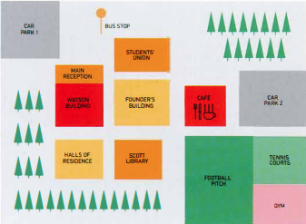 STUDENTS' UNION MAIN RECEPTION FOOTBAL PICH Sunnyhills University today 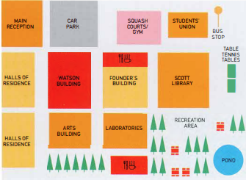 MAIN RECEPTION SQUASH COURTS/GYM HALLS OF RESIDENCE TABLE TENNIS TABLES LABORATORIESPOND

GRAMMAR FOCUS: PREPOSITIONS OF PLACE

03 | Look again at the map of Sunnyhill University campus today. Which of these sentences are true?  - The Founder's Building is between the Watson Building and the Scott Library.  - The bus stop is in the upper right-hand corner of the campus.  - The halls of residence are opposite the Students' Union.  - There are two car parks on the campus.  - There are two places to eat on the campus.  - The main reception is in the middle of the campus.  - The Students' Union moved to a different building between 1995 and today.  - The car park was moved towards the bottom of the campus. | TIP 03  Prepositions are important in any task including maps. It is important to say exactly where things are located in relation to other places.
04 | Complete the sentences about the 1995 campus map using the prepositions in the box.  between in next to of of on opposite to  - The tennis courts were --- the football pitch.  - The Founder's Building was in the middle --- the campus.  - The Scott Library was the halls of residence and the football pitch.  - The cafe was --- the football pitch.  - There were two car parks the campus.  - The gym was the bottom right-hand corner of the campus.  - The Watson Building was the left of the Founder's Building.  - The main reception was part the Watson Building.
05 | Complete the sentences to describe the map of the campus today to your partner. You can use the expressions in the box.  between in front of in the top right-hand corner  next to on the left opposite  - The halls of residence ---  - The laboratories ---  - The bus stop ---  - The recreation area ---  - The table tennis tables ---  - The Students' Union ---

[[[[[[[[[[DESCRIBING CHANGES IN A MAP]
06 | Read this Writing Part 1 task.  You should spend 20 minutes on this task.  Look at the two maps of Sunnyhills University campus in 1995 and today.  Summarise the information by selecting and reporting the main features, and make comparisons where relevant.  You should write at least 150 words.
07 |  | There are three important parts in a Part 1 essay. Match the parts 1-3 with their meanings a-c. Then find them in the model answer.  - The introductory sentence  - The concluding sentence  - The overview  - A summary of the main points  - A description of what the data shows  - Writing the most important points again in different words | MODEL ANSWER  The two maps show changes to the campus of Sunnyhills University between 1995 and today. We can see that the university made many changes during this period, including new buildings and recreation facilities.  In the past, the Scott Library was in front of the Founder's Building. It was relocated to the right, and in addition, it increased in size. The old library building now contains laboratories. In 1995 there was a car park in the top left-hand corner of the campus, whereas now the main reception is there. The halls of residence were moved to the far left of the campus and a new Arts Building was built opposite them.  The old sports ground, gym and tennis courts were demolished; however, in their place the university created a new recreation area with a pond, trees and seating areas. What is more, the university developed new sports facilities, including table tennis tables, a new gym and squash courts. They also built two new cafes.  So, it is clear that the university changed and expanded during this period.

VOCABULARY

08 | Find these in the model answer:  - verbs describing change  - expressions describing where things are
09 | The underlined words in the model answer are useful for any essay. Among them, find two expressions which:  - mean 'and'  - mean 'but'  - refer to time  - refer to what you see in the chart or diagram | TIP 09  It is important to use plenty of different words in the essay to show you have a wide vocabulary. Make a list of similar words in your notebook and try to use them when writing your practice essays.
10 | Find words in the model answer with these meanings.  - moved to a different place  - made (2 words)  - knocked down  - got bigger (2 words)

GRAMMAR FOCUS: PAST SIMPLE - REGULAR AND IRREGULAR FORMS

11 | Find these past tense forms in the model answer. Which of them are irregular? What are the infinitives of these verbs?  expanded changed changed made built  increased developed moved was
12 | These sentences could also be used to describe the maps. Put the verb in brackets into the past tense to complete the sentences.  - They (cut) down trees to build the halls of residence.  - The old café (become) the new library.  - In 1995 students (catch) the bus outside the Students' Union.  - The university (need) laboratories.  - They (put) table tennis tables in front of the Scott Library.  - There (be) not enough halls of residence in 1995.  - They (dig) a pond in the recreation area.  - They (plant) lots of new trees.  Two of the verbs are regular. Which ones?

GRAMMAR FOCUS: PAST SIMPLE - ACTIVE AND PASSIVE

13 | Read the information about active and passive verbs.  Are sentences 1-4 about the map active or passive?  - The library was relocated to the right of the Founder's Building.  - They also built two new cafés.  - The university created a new recreation area.  - The old gym and tennis courts were demolished. | ◉ The university developed the campus during this period. - active  - The subject (the university) did the action.  - The verb is a single word (developed).  New halls of residence were built. - passive  - The subject (new halls of residence) didn't do the action (build), but someone else did the action to it.  - The verb consists of two words: the correct form of be (were) + past participle (built).
14 | Change these sentences from active to passive.  - The university expanded the campus. The campus was expanded.  - They planted trees in the recreation area.  - The authorities moved the bus stop.  - They built a new main reception.

[[[[[[[[[EXAM SKILLS]
15 | Answer the task below. Take as much time as you need and try to write 150 words.  The verbs in the box may be useful. Check the meaning of any unknown words.  add build construct create develop expand move plant trees  The maps below show Colwick Arts Centre in 2005 and today.  Summarise the information by selecting and reporting the main features, and make comparisons where relevant.  2005 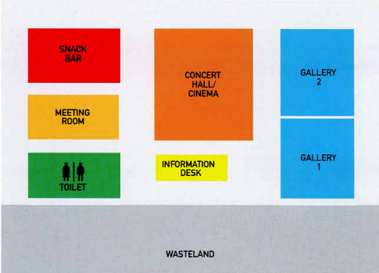 SNACK BAR MEETING ROOM TOILET CONCERT HALL/CINEMA INFORMATION DESK GALLERY WASTELAND Today 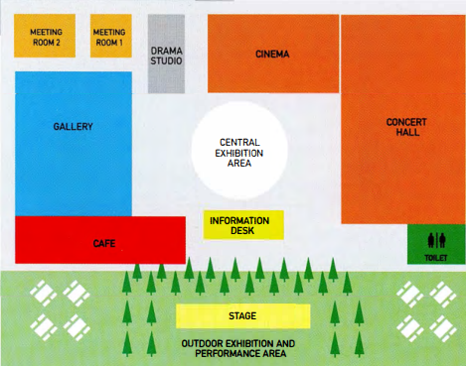 MEETING ROOM DRAMA STUDIO CINEMA CENTRAL EXHIBITION AREA CONCERT HALL STAGE OUTDOOR EXHIBITION AND PERFORMANCE AREA  Remember to:  - write an introductory sentence  - include an overview  - use the present simple and past simple, both active and passive  - use prepositions to explain where things are/were.

UNIT/03: EDUCATION AND EMPLOYMENT
LISTENING
IN THIS unIT YOU WILL
LEARN HOW TO
- answer short-answer questions
- spell names correctly.

Lead-in
01 | Here are some pictures of places in a town. Match pictures A-G with the words in the box.  railway station museum bank harbour  sports centre restaurant bus stop         
02 | Put the words in exercise 1 into the correct group. There is an example to help you.  Travel and transport: harbour, ---. ---  Sports and leisure:---, ---  Arts and culture: ---  Money: ---
03 | Put the words in exercise 1 into the correct group. There is an example to help you.  15  Conversation 1 ---  Conversation 2 ---

SPELLING NAMES

04 | Listen to the rest of conversations 1 and 2 and answer the questions.  16  Conversation 1  - What is the address of the sports website?  - www.getactive.com - www.getaktive.com  Conversation 2  - What is the man's name? James ---  - What is his address? --- Road | ◉ In Section 1 of the Listening test you may have to write the name of a person, a place or a website. Usually the names will be spelled for you. You need to know the letters of the English alphabet so that you can write the words correctly. If you don't, your answer will be wrong. You will hear the spelling once only.
05 | Listen again and complete the extracts from the two conversations.  The first letter of each word is given to help you.  17  - 'Get active' - Is that a __ o __ w __ ?  - Is that[ ... ] w __ an 'e' or without?  - It's got an 'e' at the e __ .  - Is that[ ... ] with ad __ 'd', did you say?
[[[[[[[[[[SHORT-ANSWERQUESTIONS]

06 | Read the questions and underline the key words.  The first one has been done for you.  - What did the speakers order in the restaurant?  - How much did each person pay for their meal?  - What time is the bus due?  - Where is the bus stop?  - How long did the course last?  - Which TWO things did the speaker do on the course?  - What is the date of the next course?  - Who will lead the course? | ◉ You often use short answers in note completion tasks. In this type of task you answer questions using up to three words, or two words and/or a number.
07 | Complete the table. Use the key words in the questions in exercise 6 to help you. The first one has been done for you.  Which questions need ••• Question  - a date - a price - a period of time - a time - a meal or a kind of food - a name of a person - the names of activities or skills - a place? 7

08 | Look at the table you completed in exercise 7. For which questions do you need to write a number?
09 | Listen to the conversation and answer the questions.  Write NO MORE THAN ONE WORD AND/OR A NUMBER for each answer.  18  - What did both speakers order?  - How much did each person pay for the meal? £
10 | Read this question about a shopping trip, and choose the correct answer.  Why is the other answer incorrect?  Answer the question. Write NO MORE THAN ONE WORD AND/OR A NUMBER for each answer.  What did the boy buy in the shopping mall?  Answer: shoes / he bought shoes | TIP 10  It is important to check the instructions carefully to see how many words you can write in your answer.
11 | Listen to the conversation and choose the correct answers.  Why are the other answers incorrect?  Answer the questions. Write NO MORE THAN ONE WORD AND/OR A NUMBER for each answer.  19  - What time is the bus due?  seven fifteen / seven fiftty/7.15/7.50 pm  - Where is the bus stop?  Blithe Road / Blith Road / Blythe Road / Blyth Road | TIP 11  It is important to check your spelling carefully. If you spell the word incorrectly, your answer will be marked wrong. When you need to answer a question with a number, it is easier and quicker to write it as a number rather than writing it in words. And also you are less likely to make a mistake.

12 | Listen to Alicia telling a friend about a sailing course and answer the questions.  Write NO MORE THAN ONE WORD AND/OR A NUMBER for each answer.  20  - How long did the sailing course last?  - What was the first thing that Alicia learnt?  - What is the date of the next course?  - Who will lead the next course?

[[[[[[[[[[EXAM SKILLS]

13 | Read questions 1-8 below. For which questions do you need to write a number ONLY?
14 | Find the key words in questions 1-8 below.
15 | Listen and answer questions 1-8.  Then read your answers carefully.  21  - Did you check your spelling?  - Did you write numbers in digit form?  - Did you check that you have written the correct number of words?  Questions 1-5  Answer the questions below. Write NO MORE THAN TWO WORDS AND/OR A NUMBER for each answer.  - 1 What kind of tour did the woman do?  - How did she find out about the tour?  - How many people were on the tour?  - What is the address of the hire shop?  - How much did each student in the group pay? $  Questions 6-7  Which TWO items were included in the cost of the hire?  6  7  Question 8  What is the website address of the hire shop?

UNIT/03: EDUCATION AND EMPLOYMENT
SPEAKING
IN THIS unIT YOU WILL
LEARN HOW TO
- use prepositions to talk about your home town
- use adjectives to describe your home town
- use the correct tense when responding to questions
- pronounce regular and irregular past simple tense endings.

Lead-in

01 | What tense would you use to answer these questions? Select the correct answer A-C below.  - Is there much for young people to do in your home town?  - What was your home town like in the past?  - Has your home town changed since you were a child?  - Present perfect, e.g. Many things have changed in my home town over the years.  - Present simple, e.g. There are lots of things for young people to do in my home town.  - Past simple, e.g. There were more factories and the houses were smaller.
02 | Now, with a partner, ask and answer the three questions in exercise 1.

[[[[[[[[[[ANSWERING PART 1 QUESTIONS]

USING PREPOSITIONS TO DESCRIBE YOUR HOME TOWN

03 | Listen to a boy describing his home town and read the script.  Match the places the boy talks about with A - H on the map.  22  town hall H library art gallery cinema  shopping mall harbour stadium swimming pool  Well, I live in a small town in the north of my country. It has quite a few interesting places to visit. For example, in the centre of town, on the north side of the square we have the historic town hall, which was built in 1895. In front of it, there's a beautiful fountain. Opposite the town hall there's the library. Then if you go over the bridge, we have the art gallery, a big modern building, which often has interesting exhibitions. The art gallery is actually between the cinema (to the north) and a big shopping mall, where I often meet up with my friends. To the south of the town, there's a harbour, where you can take a boat to the islands. And then next to the harbour is the stadium, where people go to watch our local football team. And just behind it is the public swimming pool. It's an outdoor pool-lovely in summer, but very chilly the rest of the year. 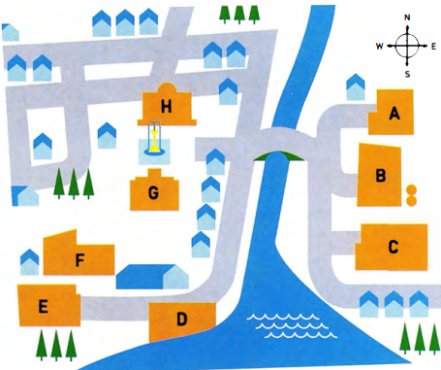
04 | Now describe your home town. You might want to draw a map to help you.

USING ADJECTIVES TO DESCRIBE YOUR HOME TOWN

05 | Choose the correct heading from the box for the words and phrases in the table below.  Areas Buildings Climate Location Opinion  1 Location 2 ----- 3 ----- 4 ----- 5 -----  on the coast in the north-east in the centre outdoor inland busy crowded dirty exciting lively quiet hot humid mild industrial business financial tall historic ordinary modern old

06 | Look at the words and phrases in the box and write them in the correct column of the table in exercise 5.  ancient colourful cool enormous high-rise  tourist in the south indoor incredible magnificent  narrow polluted huge  With a partner, add two more adjectives of your own to the table.
07 | Complete the sentences with pairs of adjectives from the table in exercise 5.  - I come from a very modern city. You can see --- and --- buildings everywhere.  - In summer it's very wet and uncomfortable in my town. It's very --- and ---.  - There's usually a light breeze from the sea, so it's very --- and ---.  - There's a lot of rubbish on the streets. It's quite --- and ---.  - There's a great atmosphere in my city, especially at night. It's very ---- and ---. | TIP 07  It is a good idea to use pairs of words with similar meaning when you talk about your home town.  This shows the examiner that you have a good range of vocabulary.  For example: A lot of people live and work in my city. It's very busy and crowded.
08 | Look at the photographs below. Try to describe each place using the headings and the words in exercise 5.  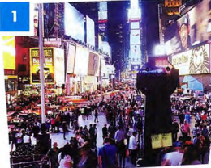 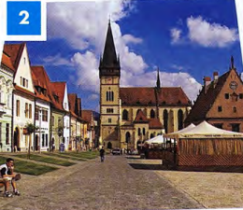 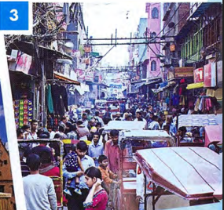

GRAMMAR FOCUS: TENSES

09 | Read the questions on the examiner's card.  Then match them with the verb tenses.  Let's talk about the town or city where you grew up.  - Where did you grow up?  - Is it a good place to live?  - Do you think it has changed a lot? How?  present simple present perfect past simple | ◉ In Part 1 of the Speaking test the examiner will ask you questions about familiar everyday topics such as your home town. To answer the questions you might need to use a range of tenses.  TIP 09  It is important to listen very carefully to the questions the examiner asks you. This will help you to decide how to form your answer and what tense to use. One thing you can do is repeat or 'echo' the examiner's question to help you do this, but don't do this too often!

11 | Read the Part 1 questions from different Speaking tests and choose the correct tense in the candidates' responses.  Examiner Where were you born?  Candidate 1 I (1) am / was born in Dubai, in the Middle East. It (2) is / was as situated on the north-east coast of the United Arab Emirates.  Examiner Where did you grow up?  Candidate 2 I (3) am / was born in a small village in China, but I (4) grow up / grew up in Chengdu, which (5) is / was a very big city in south-west China.  Examiner Has your home town changed much since you were a child?  Candidate 3 In the last ten years Baku (6) changed / has changed a lot. Ten years ago we (7) haven't had / didn't have so many tall buildings and there (8) isn't / wasn't as much to do then. The biggest problem is that everything (9) is / was more expensive now.  Examiner Is there anything that you used to do in your home town that you don't do now?  Candidate 4 Well, I (10) used to / was used to go to the beach every summer when I (11) have been / was younger, but now I don't have time. One summer, I even (12) used to go/ went fishing. I'd like to do that again. Perhaps I'll have time next summer after my exams.  Listen and check your answers.  23
12 | Listen to the sentences and tick the correct column, /t/, /d/ or /ɪd/ according to how the verb ending is pronounced.  24  /t/ /d/ /ɪd/ - bought - built - situated - called - located - changed /t/ /d/ /ɪd/ - developed - designed - discovered - started - used to - said | ◉ In the past simple, the ending of the verb can be pronounced in one of three ways: /t/, /d/ and /ɪd/.  Examples:  /t/ work-worked  /d/ play-played  /ɪd/ decide-decided

13 | Complete the sentences with ideas of your own. Then say them to your partner, pronouncing the verb carefully.  - Our family bought --- in the middle of town.  - The --- was built in ---.  - Our town is situated ---.  - The --- is called 'the ---.  - --- is located across from the ---.  - --- have/has changed over the years in my home town.  - --- was/were developed by the harbour.  - --- was designed by ---.  - Recently, scientists discovered --- near our village.  - Recently, many young people have started to ---.  - A long time ago many people used to ---.  - A tourist who visited recently said our town is ---.
14 | Read an examiner's questions, then listen to four students answering them. Match the speakers 1-4 with the examiner's questions a-d.  25  - What is your favourite place in your town?  - What do people do for fun in your town?  - Is it easy to travel around your town?  - What is the oldest part of your town?  Speaker 1 --- Speaker 2 ---  Speaker 3 --- Speaker 4 ---  Now ask and answer questions a-d with a partner.
[[[[[[[[[[EXAM SKILLS]

15 | Ask and answer the questions below about your home town with a new partner.  Listen to your partner's answers and note any new ideas or vocabulary you hear. Then, ask and answer the questions again and try to improve your answers.  - Can you describe the town where you grew up?  - What places of interest are there in your home town? Where are they?  - Is it a good place for young people? Why?  - Where do young people in your town meet their friends?  - What is your town like at night?  - How has your town changed in the last 10 years?  - Have any new buildings been built?  - A long time ago, where did people from your town used to work?

